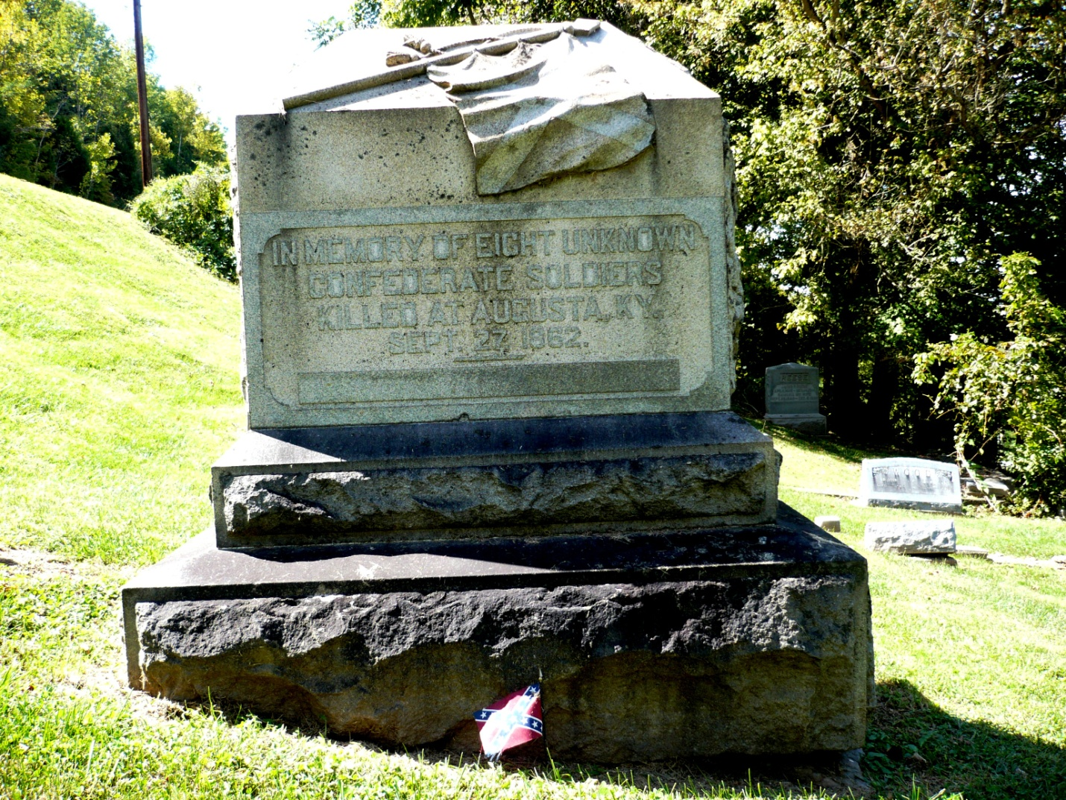
The Confederate Monument honors eight unknown soldiers who died attacking Augusta in September 1862. In 1903, the present monument was placed at their burial spot located in Payne Cemetery on the river side of Kentucky State Route 8.
The monument is a granite tombstone four feet high with a base three feet wide. At the top of the tombstone is the Confederate battle flag. The stone was placed where the unknown soldiers were buried, forty-one years after the skirmish in which they were killed.
The monument cost was $550. The John B. Hood Camp of the United Confederate Veterans was responsible for the funding for the monument.
On July 17, 1997, the Confederate Monument in Augusta was one of sixty-one different monuments related to the Civil War in Kentucky placed on the National Register of Historic Places. It is the most northerly of the monuments on the list that honor only Confederates.
The monument is best reached from the parking area by the flagpole on the river side of Kentucky State Rt. 8.
***source: http://en.wikipedia.org/wiki/Confederate_Monument_in_Augusta

